  
  
**Tribhuvan University**

**Faculty of Humanities and Social Science**

**Hotel** **Reservation System**

**A PROJECT REPORT**

**Submitted to**

**Department of Computer Application**

**Swoyambhu International College**

***In partial fulfillment of the requirements for the Bachelors in Computer Application***

Submitted by

Srijana Bista (6-2-927-27-2020)

Roll no: 27

September 2024

Under the supervision of

**Sujit Gyawali**



**Tribhuvan University**

**Faculty of Humanities and Social Science**

**Swoyambhu International College**

**Supervisor’s Recommendation**

I hereby recommend that this project prepared under my supervision by Srijana Bista “**Hotel Reservation System”** in partial fulfillment of the requirements for the degree of Bachelor of Computer Application is recommended for the final evaluation.

**SIGNATURE**

Sujit Gyawali

**SUPERVISOR**

Department of BCA

Swoyambhu International College

Lagankhel, Lalitpur 



**Tribhuvan University**

**Faculty of Humanities and Social Science**

**Swoyambhu International College**

**LETTER OF APPROVAL**

This is to certify that this project prepared by Srijana Bista “ **Hotel Reservation System”** in partial fulfillment of the requirements for the degree of Bachelor in Computer Application has been evaluated. In our opinion it is satisfactory in scope and quality as a project for the required degree.

|  |  |
| --- | --- |
| ………………………..………………..  **Signature of Supervisor**  **Sujit Gyawali**  Lecturer  Swoyambhu International College  BCA | ……………………………………………  **Signature of Coordinator**  **Raj Kumar Sah**  Coordinator  Swoyambhu International College  BCA |
| …………………………………………  **Signature of Internal Examiner** | ……………………………………………  **Signature of External Examiner** |

# ABSTRACT

Accessibility and convenience are critical in the fast-paced world of today. More people are turning to online solutions for their daily needs as a result of the growing usage of the internet. There has never been a greater need for easy online hotel booking services, and the hospitality sector is no exception. By developing an online platform that makes it simple for consumers to find, book, and manage their hotel reservations, this project seeks to close the gap in the conventional hotel booking process. Despite its steady growth, the hotel sector frequently uses manual procedures and third-party middlemen, which can result in inefficiencies, communication problems, and booking delays. This initiative aims to provide a streamlined solution that benefits both hotel owners and guests by digitizing hotel reservations.

Potential visitors will be able to explore hotels, view room details, check pricing, check availability and make immediate reservations using our all-inclusive hotel reservation system without having to get in touch with the hotel directly or rely on middlemen. Additionally, the technology will give hotel managers pricing updates, and room availability management.

This project's main goal is to improve the user experience by providing a safe, dependable, and effective booking procedure. With just a few clicks, visitors can quickly book their stays and search for hotels by room type, or price.

Keywords: Hotel Reservation System ,digitalization, hotel management, user-friendly.

# ACKNOWLEDGMENT

First of all, I would like to express my gratitude towards my project management teacher **Mr. Sujit Gyawali** sir who guided and assisted me for doing this project. He provided essential guidance and references without whom this project couldn’t be completed. He guided me in every possible way to make me able to complete this project. I am also thankful towards our college management team for providing essential tools and helping in this project.

I would like to thank my parents for their immense support and encouragement for making this project successful. Besides, I would really like to thank my friends for helping us in completing this project.

Lastly, I would like to sincerely thank the Dean's Office at Tribhuvan University (FOHSS) for giving the chance to complete this worthwhile project as a requirement for the BCA program. Our practical knowledge and skills have improved greatly as a result of this initiative, and we anticipate that it will have a big impact on how we develop in the future.

**Srijana Bista**

**BCA 6th Semester**

# Table of Contents

ABSTRACT i

ACKNOWLEDGEMENT ii

LIST OF TABLES v

LIST OF FIGURES vi

LIST OF ABBREVIATIONS vii

1. INTRODUCTION 1
   1. Introduction 1
   2. STATEMENT OF PROBLEM 2
   3. OBJECTIVES AND FEATURES 2
      1. Objectives: 2
      2. Features: 2
   4. Scope and Limitation 2
      1. Scope 2
      2. Limitation 2
   5. Report Organization 2
2. BACKGROUND STUDY AND LITERATURE REVIEW 3
   1. Background Study 3
   2. Literature Review 3
3. SYSTEM ANALYSIS AND DESIGN 6

3.1 System Analysis 6

3.1.1 Requirement Analysis 7

3.1.2 Feasibility Analysis 9

3.1.3 Technical Feasibility 9

Operational Feasibility 9

Economic Feasibility 9

Sceduling………………………………………………………………………. 10

3.1.4 ER Diagram 11

3.1.5 Data Flow Diagram 12

3.2 System Design 13

3.2.1 Architectural Design 13

3.2.2 Database Schema 13

3.2.3 Interface Design 14

3.2.4 Physical DFD 16

3.2.5 Algorithm Details 17

4. IMPLEMENTATION AND TESTING 20

4.1 Implementation 20

4.1.1 Tools Used 20

4.1.2 Implementation details of modules 21

4.2 Testing 23

4.2.1 Test cases for Unit Testing 23

4.2.2 Test cases for System Testing 25

5. CONCLUSION AND FUTURE RECOMMENDATIONS 26

5.1 Conclusion 26

5.2 Future Recommendations 26

REFERENCES 27

APPENDICES 29

Algorithm Codes………………………………………………………………………30

# LIST OF TABLES

Table 3-1: Scheduling of Hotel Reservation System. 10

Table 4-1 : Register page Test Case of Hotel Reservation System 23

Table 4-2 : Login page Test case of Hotel Reservation System . 24

Table 4-3: System testing test case of Hotel Reservation System 25

# LIST OF FIGURES

Figure 3-1: Waterfall Software Development Model 6

Figure 3-2: Use-Case Diagram of Hotel Reservation System 8

Figure 3-3:Gantt Chart of Hotel Reservation System 10

Figure 3-4: ER Diagram of Hotel Reservation System 11

Figure 3-5: DFD Level 0 of Hotel Reservation System. 12

Figure 3-6: DFD Level 1 of Hotel Reservation System 12

Figure 3-7: Architectural Design of Hotel Reservation System ………...……………13

Figure 3-8:Database Schema of Hotel Reservation System 13

Figure 3-9: Home Page Design of Hotel Reservation System 14

Figure 3-10: Signup Page Design of Hotel Reservation System 14

Figure 3-11: Contact us Page Design of Hotel Reservation System 15

Figure 3-12: Booking Page Design of Hotel Reservation System 15

Figure 3-13: Physical DFD of Hotel Reservation System 16

Figure 3-14: Linear Search Flowchart of Hotel Reservation System 18

Figure 3-15: Binary algorithm flowchart of Hotel Reservation System. 19

# LIST OF ABBREVIATIONS

**CSS**: Cascading Stylesheet

**HTML**: Hypertext Markup Language

**JS:** JavaScript

**My SQL**: My Structured Query Language

**HRS**: Hotel Reservation System

**PHP**: Hypertext Preprocessor

# Chapter-1: Introduction of Project

## 1.1 Introduction

### The Hotel Reservation System is a web-based system that allows users to search for hotels, check availability, and make online reservations. It includes admin and user modules where customers can explore hotels, verify room availability, and make reservations using the User Module by room type and price.

### The Admin Module, on the other hand, is made to help hotel management monitor and manage several areas of the hotel's operations. This include processing bookings, maintaining room availability, adding and updating room details and managing users. In addition, administrators have the ability to keep an eye on user input and apply dynamic pricing in response to variations in demand, such as seasonal or event-specific spikes.

### The search algorithm of the hotel booking system, which effectively locates available rooms based on user requirements, is a key component. By filtering rooms based on room type and price, it guarantees quick results. Bookings may be found on the admin side using linear search, which is based on specific information like name, address, or phone number. Smaller or unsorted datasets are better suitable for linear search than binary search. It is easy to use but efficient for the administrator's needs because it checks each element in the dataset individually until it discovers match. The system use binary search on the user's end to locate hotel rooms fast depending on particular parameters like price and room type. An effective technique for sorting data, binary search aids the system in rapidly reducing the number of search results. The system initially arranges the available rooms by price and room type when users search for accommodations.

## 1.2 Statement of Problem

### No guarantee of room availability.

### Manual Booking Errors.

* Limited Customer Reach.

## 1.3. Objectives

The main goal of our project are:

* To Simplify the booking process by giving customers quick reservations.
* To enhance hotel management by automating room allocation and bookings.

## 1.4. Scope and Limitation

Every project has it’s scopes as well as some limitations. Our project also includes some of the scopes and limitations which are mentioned below:

### **1.4.1 Scope**

* It includes room search and booking featuring real-time availability and choices for room type.
* It includes booking experience by creating an account that enables customers to handle reservations.

### **1.4.2 Limitation**

Hotel Reservation system only involves booking hotels by the customers but for now there is no payment integrating feature available. It may be added in the future.

## 1.5 Report Organization

This report document contains five chapters including this chapter. Chapter one defines introduction, problems, objectives, scopes and limitations. Chapter two defines and describes Background Study and Overview of related existing systems. Chapter three presents System Analysis and Design including Requirement Analysis and Feasibility Analysis. Similarly, chapter four presents the Implementation and Testing. Finally, in chapter five, Conclusion, Limitations and Future Enhancement are briefly explained.

# Chapter-2: Background Study and Literature Review

## Background Study

In existing hotel booking systems, reservations are often managed through manual processes, requiring guests to fill out forms and wait in long lines for check-in. To streamline this process, an of Hotel Reservation System has been developed, allowing users to book accommodations conveniently online. This system not only simplifies the booking experience for guests but also reduces the workload for hotel staff, enabling them to focus on providing better service. Given terminology explains it more:

* User can create their account through registration process.
* The registered users can login and can access the hotel rooms.
* The logged in users then can search the rooms based on room type and book the rooms providing their certain details at their convenience.

## Literature Review

Overview of Hotel Reservation System: Usually through web and mobile applications, of Hotel Reservation System (HRS) allow users to search, evaluate, and reserve hotel rooms online. From manual or phone-based reservations to complex platforms that provide real-time availability, dynamic pricing, and improved user interaction, these systems have seen tremendous evolution.

Hotel Reservation System, have had a profoundly positive impact on hotels, changing how they handle reservations and engage with guests. Various variables influencing customer satisfaction, that is, online satisfaction and offline satisfaction leading to the intention to book a hotel online. [1]. Additionally, hotels can collect useful consumer data for improved decision-making thanks to HRS. All things considered, HRS have created new competitive hurdles in addition to growth potential.

The success of Hotel Reservation System (HRS) is largely dependent on the user experience.  Consumers may have greater booking intention if the product quality is reasonable as compare to the market (Grewal et al., 1998). The hotel management takes different incentives to attract customers like unique and attractive images that differentiate one hotel from others, and consumers normally purchase or hire the services of well-established brand names (Aghekyan-Simonian et al., 2012). [2] Customers were more likely to complete reservations and come back for additional nights when they encountered smooth booking procedures, detailed room descriptions. Additionally, user loyalty and trust were further increased by prompt customer service and simple payment options. As Hotel Reservation System (HRS) handle sensitive consumer data and financial transactions, security is a top priority. Sharma and Verma's (2021) study looked at the security features of HRS and emphasized the value of multi-factor authentication, secure payment gateways, and data encryption in safeguarding user information. In order to reduce the chances of fraud and data breaches, the study suggested conducting frequent security assessments and adhering to industry standards. Ensuring the booking website is legitimate and secure and use of strong, unique passwords for each booking platform are the security involved. [3] This improves user confidence and promotes repeat reservations.

There are a number of difficulties in creating an effective and scalable HRS. Important challenges were noted in a study by Patel and Shah (2018), including managing varying demand, guaranteeing prompt and accurate booking confirmations, and integrating real-time availability data from several hotels. A hotel booking app’s success largely depends on its user interface (UI). Users expect an intuitive, easy-to-navigate interface that simplifies the booking process. A cluttered or confusing UI can lead to user frustration, resulting in high bounce rates and low conversion rates. [4] Another major difficulty for engineers was to retain a user-friendly interface while guaranteeing strong backend security and performance. The system's ability to manage high traffic levels, particularly during busy times of the year, is still of utmost importance.

As mobile devices become more widely used, HRS mobile applications have become increasingly popular. Users favored platforms with user-friendly interfaces, rapid booking confirmations, and mobile-specific features, according to Lee et al.'s (2020) investigation of the rising popularity of mobile booking apps.

Evaluation of Related Projects: Booking.com, a well-known international website that enables customers to look for and reserve hotel rooms anywhere in the globe, is an illustration of a successful HRS. With more than 28 million listings in 228 countries since its 1996 launch, Booking.com has expanded to become one of the biggest online travel agencies (OTAs). The platform is a popular resource for travelers since it offers features like user ratings, real-time room availability, and a secure payment method. By enabling customers to make reservations while on the go and streamlining the booking process, its mobile app has further broadened its user base.

# 

# Chapter- 3: System Analysis and Design

## **3.1 System Analysis**.

System analysis and design of Hotel Reservation System involves understanding the requirements, defining system components, and creating a blueprint for its implementation. Software can be developed using various models such as waterfall model, agile model, iterative model and so on.

In this project, we are choosing waterfall model which is a linear and sequential approach to software development that consists of distinct phases such as requirements, design, implementation, testing, deployment, and maintenance where each phase is completed before moving on to the next one.

* Requirement gathering.
* System design.
* Implementation the design.
* Integration and testing of the system.
* Deployment of the system.
* Maintenance of the system.

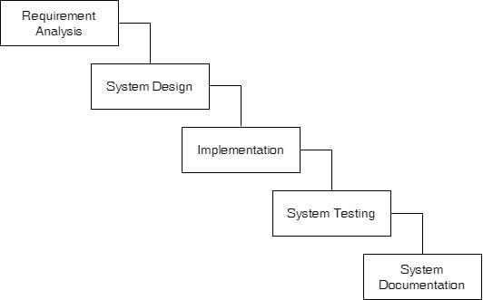

**Figure 3-1: Waterfall Development Model**

We are using waterfall model in our project because this method is easy to use and the requirements for our projects are well known. Our project doesn’t need much changes in its functions and features and includes the completion of each phase before moving to another which makes it easier to use waterfall model in our project.

## 3.1.1 Requirement Analysis

1. **Functional Requirements**
2. **User Module**

* Users can register and login the system.
* Users can search and view the hotels based on room types and price.
* Users can book the hotels.
* Users can logout from the system.

1. **Admin Module**

* Admin can login the system.
* Admin can add and delete room.
* Admin can add or delete user.
* Admin can see the total booking.
* Admin can approve the bookings.
* Admin can logout from the system.

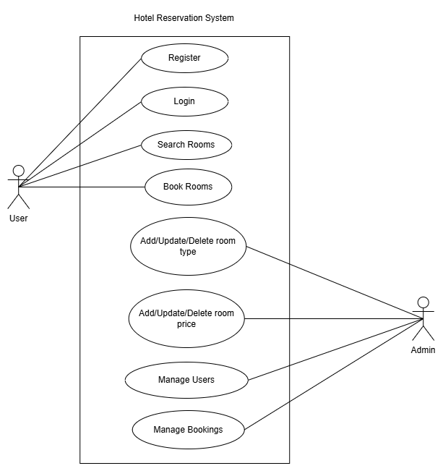

**Figure 3-2: Use Case Diagram of Hotel Reservation System**

1. **Non-Functional Requirements.**

* Performance in terms of response time, throughput, and resource utilization.
* Ability to operate without failures and ensure data integrity.
* Focuses on the user interface and user experience, ensuring the system is easy to use.

### **3.1.2 Feasibility Study**

**Technical Feasibility** Our project includes HTML, CSS, Javasrcipt, MySQL database, PHP, Ms Word, Ms Visio, VS Code, Apache(XAMPP), laptop, keyboard and mouse. All of these requirements are easily available and easy to as well. It is feasible for this project as the technical requirements can meets our laptop configuration. As these requirements are open source, easily available and easy to work on, it is technically feasible for our project.

**Operational Feasibility**

Operational feasibility focuses on how well the technology fits into the staff and management's current procedures and workflows. This entails evaluating the accessibility of resources like staff, booking management software, and room inventories In addition, the system's capacity to expedite reservations saves time and lessens the manual labor required of employees, making its implementation practical and effective for hotels. The solution maximizes resource usage while increasing overall guest experience through increased operational efficiency.

**Economical Feasibility**

The cost of hotel reservation system can vary depending on its and the particular needs of the hotel's operations. The size of the hotel, the quantity of rooms that can be reserved, the features that are needed including payment integration and the costs related to system development and maintenance are some of the factors that affect the price. This project makes sure that the whole expenditure is still financially reasonable by focusing on a particular hotel or a small number of properties and a defined set of functionalities. This focused strategy satisfies the hotel's operational requirements while enabling more effective resource allocation and cost management.

**Schedule Feasibility**

It involves assessment of whether a proposed schedule or timeline for a project, task, or event is realistic and achievable. It involves evaluating various factors to determine if the planned schedule can be met without encountering significant delays or issues. The below given charts shows the plan of our project.

**Table 3-1: Scheduling**

|  |  |  |
| --- | --- | --- |
| **Work** | **Starting Date** | **End Date** |
| **Requirement Analysis** | **28th May 2024** | **22nd June 2024** |
| **System Design** | **23rd June 2024** | **30th July 2024** |
| **Implementation** | **1st August 2024** | **15th August 2024** |
| **Integration and Testing** | **16th August 2024** | **15th September 2024** |
| **Documentation** | **16th September 2024** | **30th September 2024** |

|  |  |  |  |  |  |  |  |  |  |  |
| --- | --- | --- | --- | --- | --- | --- | --- | --- | --- | --- |
| **Work** | **Month** | | | | | | | | | |
| **May** | | **June** | | **July** | | **August** | | **September** | |
| **Requirement Analysis** |  |  |  |  |  | |  | |  | |
| **System Design** |  | |  |  |  |  |  | |  | |
| **Implementation** |  | |  | |  |  |  |  |  | |
| **Integration and Testing** |  | |  | |  | |  |  |  |  |
| **Documentation** |  | |  | |  | |  | |  |  |

**Figure 3-2: Gantt Chart of Hotel Reservation System**

### **3.1.3 Data Modeling (ER Diagram)**

An Entity-Relationship (ER) diagram is a visual representation used to model the structure of a database or information system. It is particularly useful in database design to illustrate the entities (things or objects) within a system, the attributes (properties or characteristics) of those entities, and the relationships between the entities.

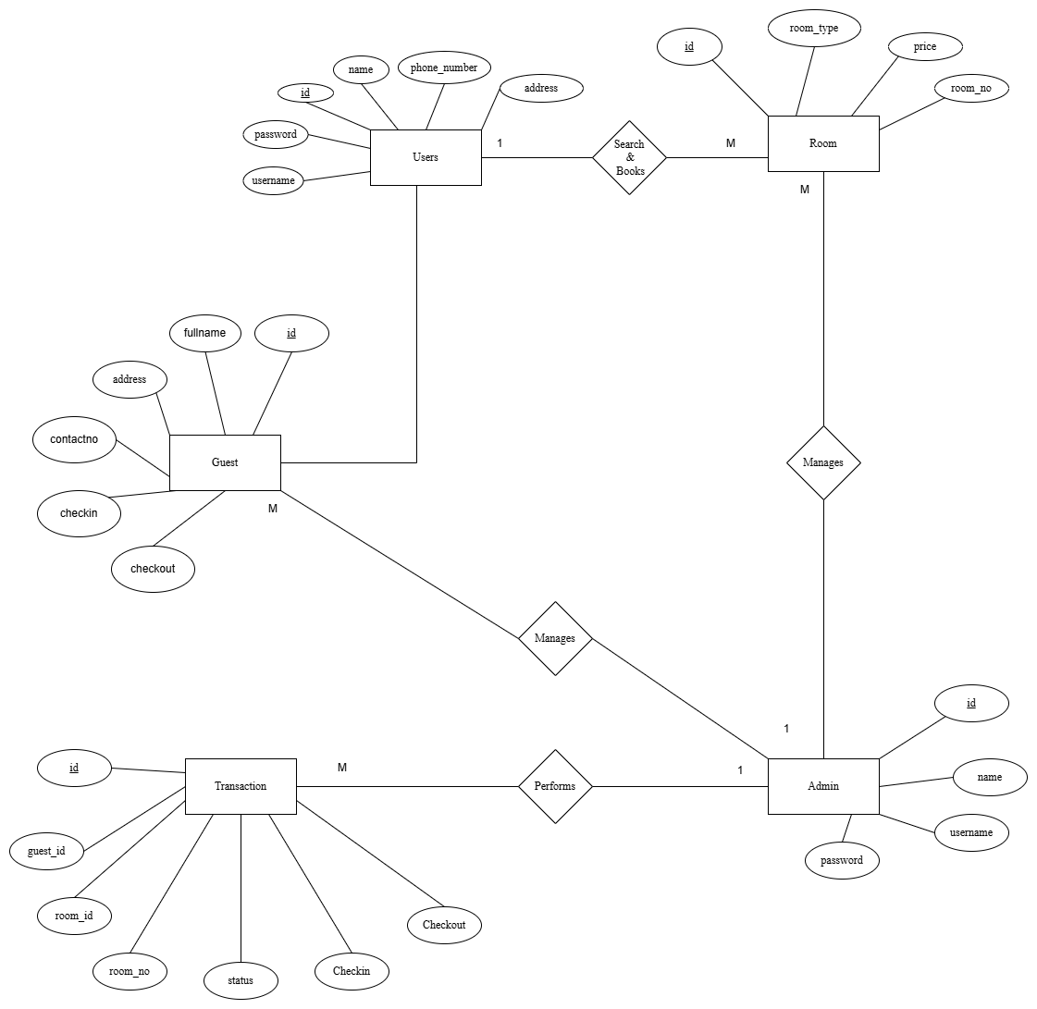

**Figure 3-4: ER Diagram of Hotel Reservation System**

### **3.1.4 Data Flow Diagram**

A data flow diagram is a way of representing the flow of data through a process or a system. It describes the information transferring from different parts of a system. is a graphical representation of how data flows within a system. It illustrates the flow of data between processes, data stores, and external entities. DFDs are useful for visualizing the high-level design of a system and understanding the interactions between its components. DFDs use various symbols to represent different elements of the system.

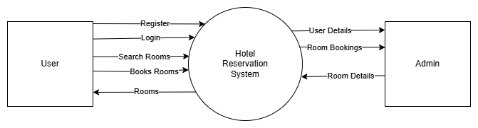

**Figure 3-5: Level 0 Data Flow Diagram of Hotel Reservation System**

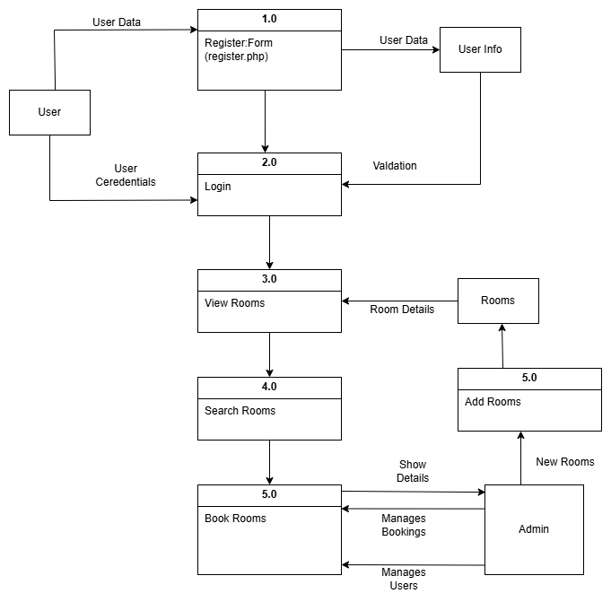

**Figure 3-6: Level 1 Data Flow Diagram of Hotel Reservation System**

## 3.2. System Design

### **3.2.1. Architectural Design**

It involves planning and structuring the software, databases, and components that allow individuals to schedule appointments for vaccinations. The 3-tier architecture involves presentation layer, application layer and data layer. The first layer in hotel reservation system is responsible for presenting the application's user interface and collecting user inputs. The second layer acts as an intermediary between the presentation tier and the data storage tier. The database layer includes data storage and manages the database system where application data is stored.

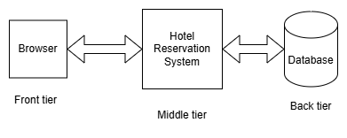

**Figure 3-7: 3-Tier Architecture of Hotel Reservation System**

### **3.2.2. Database Schema**

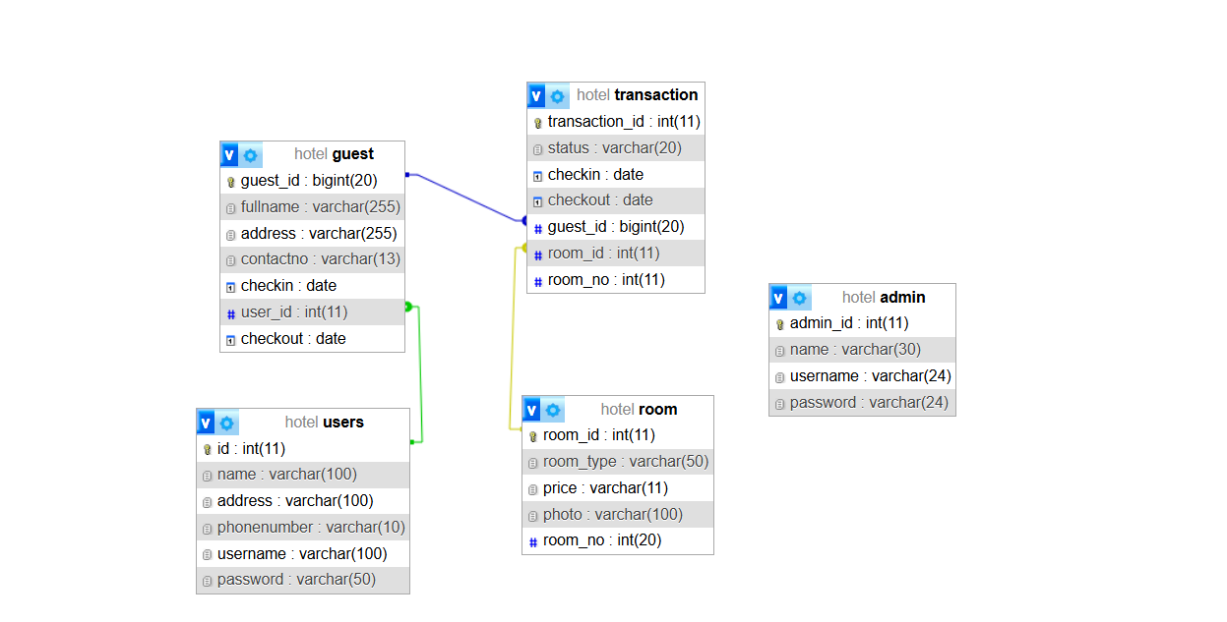

**Figure 3-8: Database Schema of Hotel Reservation System**

### **3.2.3 Interface Design (UI Interface/ Interface Structure Diagrams)**

Some of the user interface designs are constructed to visualize the user interaction with the system as they browse registration, login and perform transactions before implementing the actual design of the project. The user interface design for the website will closely align with the Functional Decomposition Diagram. The design of the web pages will be based on the functionality and structure outlined in the FDD.

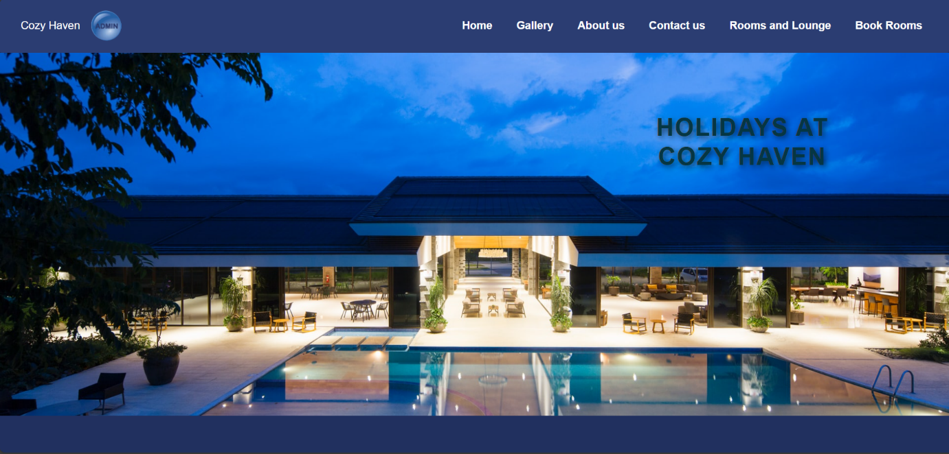**Figure 3-9 : Home Page of Hotel Reservation System**

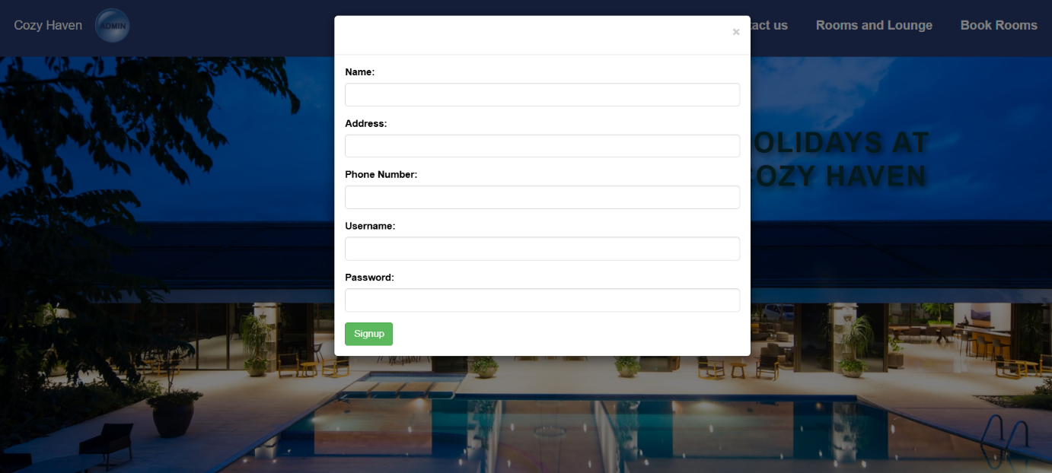

**Figure 3-10 : Signup Page of Hotel Reservation System**

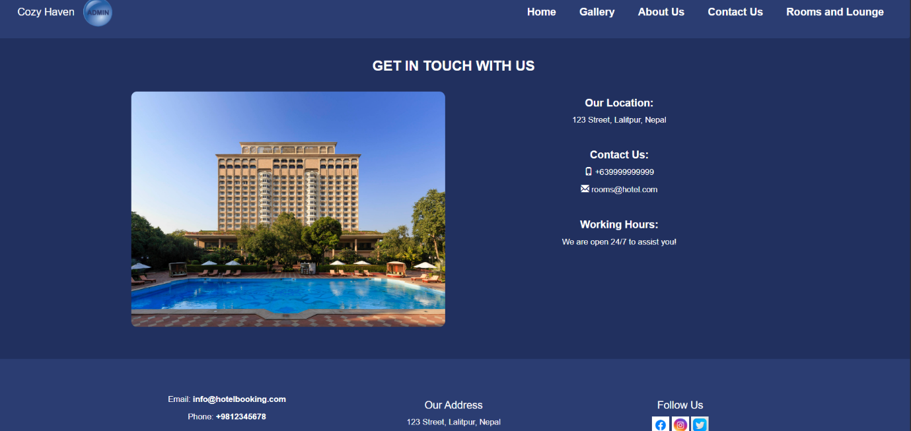

**Figure 3-11 : Contact us Page of Hotel Reservation System**

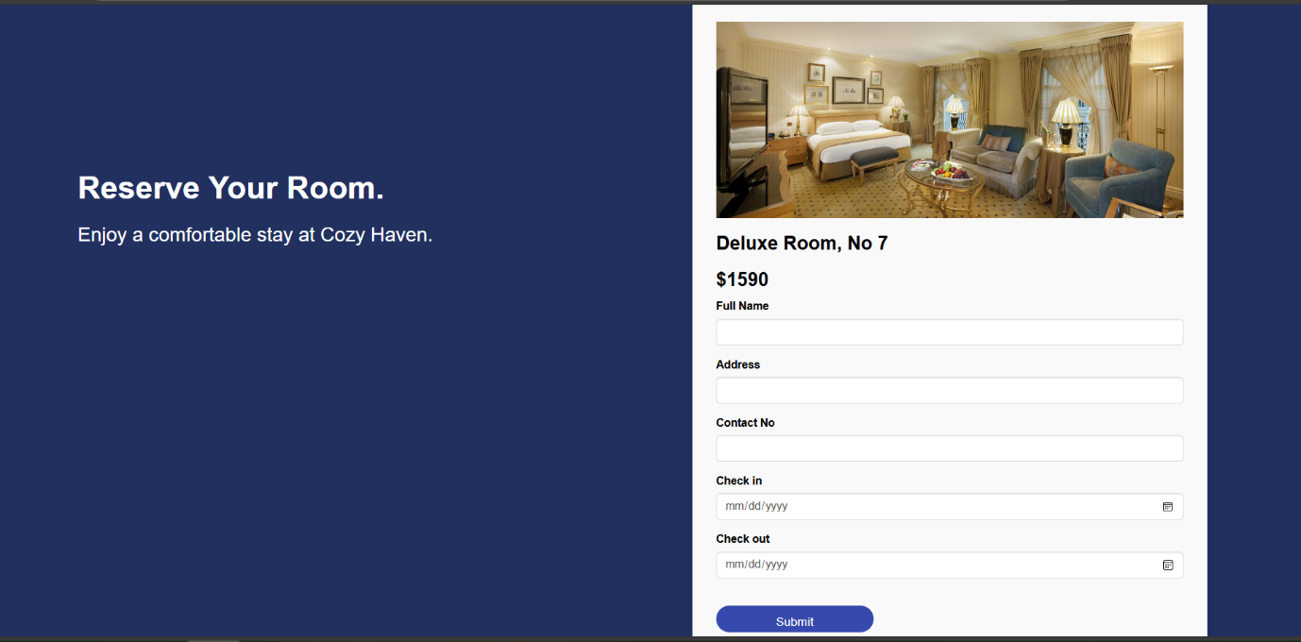

**Figure 3-12 : Booking Page of Hotel Reservation System**

## 3.2.4 Physical DFD

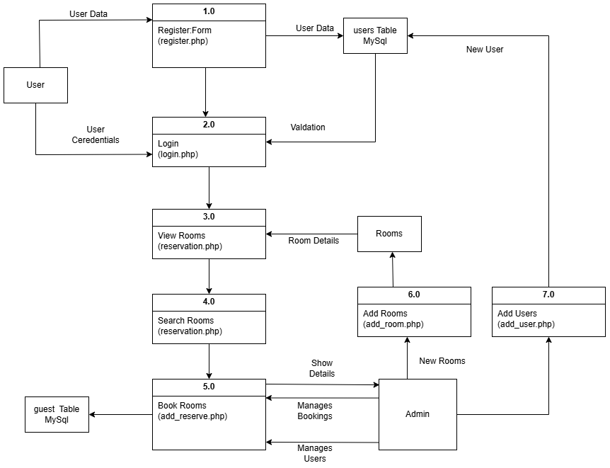

**Figure 3-13 : Physical DFD of Hotel Reservation System**

The above physical DFD shows the user and admin side where user registers, logins, serarch and books the hotel room and the admin on the other hand add rooms , manage bokings, manage users and also add users. This diagram shows the overall working of Hotel Reservation System.

## 3.2.5 Algorithm Details

**Linear Search**

* A straightforward approach for locating a particular element in a list or array is called linear search.
* It operates by going through the list one item at a time until the desired element is located.  
  The index or position of the element is returned by the search if it is located.
* The search is considered unsuccessful if the element is not located by the time the end of the list is reached.
* The list does not need to be sorted in order to use this simple approach.
* Linear search is less effective for huge datasets, but it works well for small

The admin side of the Hotel Reservation (HRS) has integrated linear search to look for reservations using visitor information like name, address, phone number, and other pertinent details. This enables the administrator to swiftly access particular reservations by manually searching through booking records.

By iterating through the list of reservations one at a time and matching the search parameters (like the guest's name or phone number), the administrator can quickly locate a guest's reservation by employing linear search. Although this approach is straightforward and efficient, it may become less successful when there are a lot of reservations because each one must be checked separately.

**Binary Search**

* An effective method for locating an element in a sorted list or array is binary search.
* It divides the search interval in half repeatedly.
* The middle member of the list is checked first by the algorithm.
* The search is finished if the middle element is the goal.
* The search proceeds to the left half of the list if the target is smaller than the middle element.
* The search moves on to the right half if the target is bigger than the center element.
* Until the element is located or the search period is empty, the procedure is repeated.
* When compared to linear search, binary search drastically lowers the number of comparisons.
* For large datasets, binary search is significantly faster due to its O(log n) time complexity.

In the HRS, binary search has been implemented on the user side to efficiently search for rooms based on specific criteria such as room type and price. Since the list of available rooms is sorted by either room type or price, binary search allows users to quickly find rooms that match their preferences.

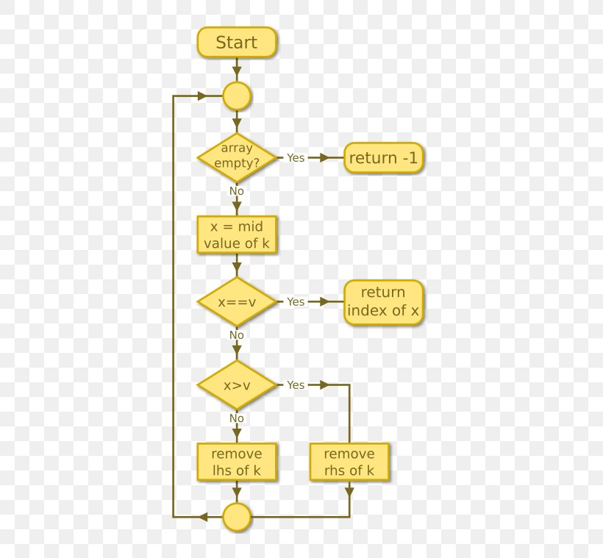

**Figure 3-14: Linear Search Algorithm Flow Chart**

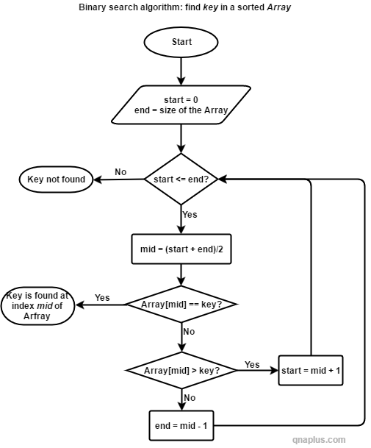

**Figure 3-15: Binary Search Algorithm Flow Chart**

# Chapter 4: Implementation and Testing

## Implementation

Implementation basically means the phase where the system is actually being built. Firstly, all the information that we gathered is studied and analyzed and implemented in a system in operation for users. It is one of the most important phases of any project. Implementation usually consists of coding, testing, installation, documentation, training and support. Different tools and technologies that have been used to develop the system which are already discussed in the previous chapter. It is basically converting system design specification into working software.

### **Tools Used**

The various system tools that have been used in developing both the front-end and back end of the project are being discussed in this chapter.

1. **Front-end:**

* **HTML5 (Hypertext Markup Language):**

HTML5 is the latest version of the standard markup language used to structure content on the web. It defines the structure and layout of your web pages using various elements like headings, paragraphs, lists, links, images, forms, and more. Each of these elements is represented by tags, which tell the browser how to render the content.

* **CSS3 (Cascading Style Sheets):**

CSS3 is a stylesheet language that controls the presentation and styling of your HTML elements. It's used to define colors, fonts, spacing, positioning, and other visual aspects of your web pages. By separating the content (HTML) from its presentation (CSS), you can achieve consistent styling across your entire website and easily make changes to the design.

* **JavaScript:**

JavaScript is a versatile programming language that brings interactivity and dynamic behavior to web pages. It allows you to manipulate the DOM (Document Object Model) in real-time, enabling actions like form validation, animations, updating content without reloading the page (AJAX), and much more. JavaScript also enables integration with APIs and other external services, making your website more powerful and interactive.

* **Bootstrap:**

Bootstrap is a popular front-end framework that provides a collection of pre-designed and responsive HTML, CSS, and JavaScript components. These components, such as navigation bars, buttons, modals, carousels, and grids, can be easily integrated into your project to ensure a consistent and visually appealing design. Bootstrap's responsive design ensures that your website looks and functions well across different devices and screen sizes.

* **jQuery:**

jQuery is a fast and lightweight JavaScript library that simplifies the process of working with HTML documents, handling events, animations, and making AJAX requests. While its prominence has somewhat decreased with the rise of modern JavaScript features, jQuery is still used in many projects for its ease of use and compatibility with various browsers.

1. **Back-end**

* **PHP (Hypertext Preprocessor):**

PHP is a server-side scripting language that is used to create dynamic and interactive web pages. It runs on the web server and generates HTML content to be sent to the user's browser. PHP can handle various tasks on the server, such as processing form data, interacting with databases, and generating dynamic content based on user inputs. It works seamlessly with HTML and can be embedded within it to create mixed content.

* **MySQL Database:**

MySQL is a popular open-source relational database management system. It's used to store and manage structured data for your web application. In MySQL, you can create tables to organize data into rows and columns, define relationships between tables, and perform complex queries to retrieve, update, or delete data. Laravel provides an elegant way to interact with MySQL and other databases through its built-in query builder and Eloquent ORM.

## 4.1.2. Implementation details of modules

Once the design was completed and the issues encountered during the design process were addressed, the development phase for the application began. Implementing an application of this scale demands significant resources, and detailing the entire implementation process falls outside the scope of this document. However, key aspects of the implementation are outlined here. Below are some of the main modules of the shopping website:

* **Header**: It displays the header with the logo of the admin, navigation or the login or register. It is used in the navbar of the homepage. It is used in order to provide links to different pages of the website.
* **Register Form**: It is used in order to register the new user to the system. It contains the text field like name, username and password etc. The information entered is further stored to be used in the login page.
* **Admin Module:** It provides information to the admin. It provides information like registered users, bookings, rooms etc.
* **Register**: Users registers into the system by filling the register form. After filling the registration form, the data is saved into the database.
* **Login**: Users login into the system by filling the login form opened into the modal. If the data sent from login form matches the data in database, the user is logged into the system.
* **Add Module**: In the system admin can add the room. All the rooms shown to the users is added by admin. This module is mainly used to add rooms.

## Testing

### **Test cases for Unit Testing**

**Table 4-1 : Register page Test Case.**

|  |  |  |  |  |  |
| --- | --- | --- | --- | --- | --- |
| T.C.  No. | Test Scenario | Test Data | Expected  Output | Actual  Output | Result |
| 1.1 | User Enters an  invalid name | username: uni1  Password: 1233 | Invalid name | As expected, | Pass |
| 1.2 | Enters string in phone field | Username: unisha  Password: 1234  Phone: 98s | Please enter a number | As expected, | Pass |
| 1.3 | Enters valid, name, address username, password and phone | Name:Unisha Bista  Address:Godawari  Phone: 9812345678  username: [unisha](mailto:abc@gmail.com) Password: 123uni | Register Successful | As expected, | Pass |
| 1.4 | Enter name as number, valid username, password and phone | Name: u123 username: unisha Password: 1234 Phone:  9800000000 | Register Successful | Name must not be in letters | Fail |

**Table 4-2 : Login page Test case.**

|  |  |  |  |  |  |
| --- | --- | --- | --- | --- | --- |
| T.C.  No. | Test Scenario | Test Data | Expected  Output | Actual  Output | Result |
| 2.1 | User Enters an invalid username, invalid Password | Username: abc Password: 123 | Invalid username or password | As expected, | Pass |
| 2.2 | User Enters an invalid username ,  valid Password | Username: abc Password: 123uni | Invalid username or password | As expected, | Pass |
| 2.3 | User Enters a  valid username and invalid Password | Username: unisha  Password: 123 | Invalid username or password | As expected, | Pass |
| 2.4 | User Enters a valid username ,  invalid Password | Username: unisha  Password: 123uni | Login Successful | As expected, | Pass |

### **Test cases for Syste**

**Table 4-3: System testing test case.**

|  |  |  |  |  |  |
| --- | --- | --- | --- | --- | --- |
| S.N. | Test Case | Input | Expected  Output | Actual  Output | Remarks |
| 1. | Register user with valid name, username, password, phone and address | Name: UnishaBista  Address: Godawari  Phone:981234567  Username: Unisha  Password: 1234 | Registration Successful | As Expected, | Pass |
| 2. | Login with valid username and password | Username: unisha  Password: 123uni | Login Successful | As Expected, | Pass |

# Chapter-5: Conclusion and Future Recommendation

## 5.1 Conclusion

The development and implementation of a Hotel Reservation System represent a significant step toward efficiently and effectively managing vaccination programs. The successful completion of this project helps the user to search the rooms and book the rooms at their convenience.

As we move forward to the project, we found that there are many features and functionalities that can be added in the future. We couldn’t add every functionalities in the given period of a time but later in the future development of this project, all those functions and features can be added.

## Future Recommendations

There are many features and improvements that can be added to the Hotel Reservation System (HRS) as it develops further in order to enhance user experience and increase the platform's functionality. One important suggestion for HRS’s future development is to incorporate a strong payment gateway, which might make reservations, special services, and hotel upgrades easier. Even though the existing system has a lot of capability, there are a few places where it might be improved and expanded:  
**Combining Machine Learning with Customization**  
By incorporating machine learning algorithms, clients can receive tailored suggestions based on their browsing history, preferences, and past reservations. By providing customized accommodation choices, seasonal discounts, and travel package offers, personalized recommendations could increase customer satisfaction and encourage bookings.  
**Improved Compatibility with Mobile Devices**  
A wider audience would find the booking system more accessible if it were optimized for mobile platforms, given the growing dependence on mobile devices. Customers can browse and book rooms more easily while on the go if a responsive mobile app is developed or the mobile-friendly online version is improved. In the hospitality industry, having an easy-to-use mobile interface could be a big competitive advantage.

**Connectivity with Well-Known Travel Websites**  
By collaborating with online travel agencies like Expedia, Airbnb, or TripAdvisor, the hotel may increase its exposure and draw in more guests. The presentation of accommodation listings across several platforms would be made possible by this integration, expanding their audience and maybe increasing reservations. The hotel's offerings would also become more credible and appealing if customer reviews and ratings from various channels were integrated.  
**Features for Advanced Booking**A greater range of client demands could be met by including options like "flexible dates," hotel upgrades, and special requests. To encourage flexibility, the variable dates feature, for instance, can let users see lower prices on several dates. The visitor experience might also be improved by enabling customers to request extras like infant cribs, airport shuttles, or special event arrangements.

# References

|  |  |
| --- | --- |
| [1] | K. Ahmad, "ResearchGate," ResearchGate, 12 12 2023. [Online]. Available: https://www.researchgate.net/publication/376544146_Hotel_Booking_Intentions_A_  Literature_Review. |
| [2] | G. R. ,. J. Z. F. U. K. Z. A. Irfan Ullah, "Science Direct," 5 2019. [Online]. Available: https://www.sciencedirect.com/science/article/abs/pii/S0969698918310282#preview  -section-introduction. |
| [3] | C. Audits, "Control Audits," 3 3 2024. [Online]. Available: https://www.controlaudits.com/blog/what-are-the-security-risks-and-solutions-for-online-hotel-booking-platforms/#:~:text=%E2%80%93%20Ensure%20the%20booking%20website%20is%20legitimate%20and,unsolicited%20contact%20prompting%20for%20personal%20or%20payment. |
| [4] | C. Infotech, "Vooinc," 29 8 2024. [Online]. Available: https://vooinc.com/hotel-booking-app-development-key-challenges-and-solutions/. |

# Appendices

# 

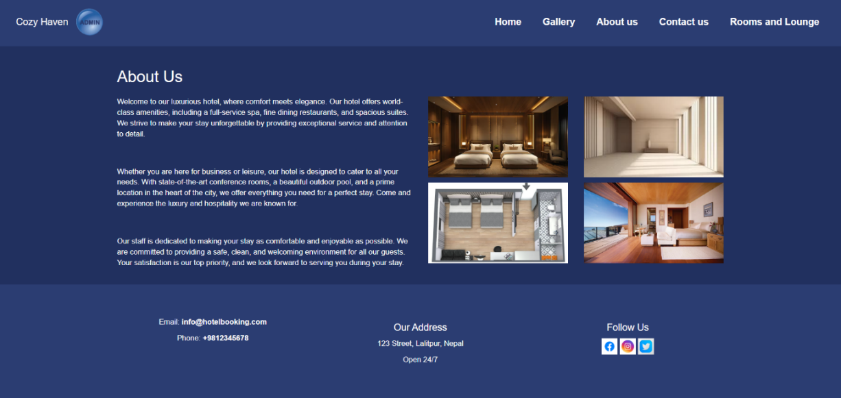

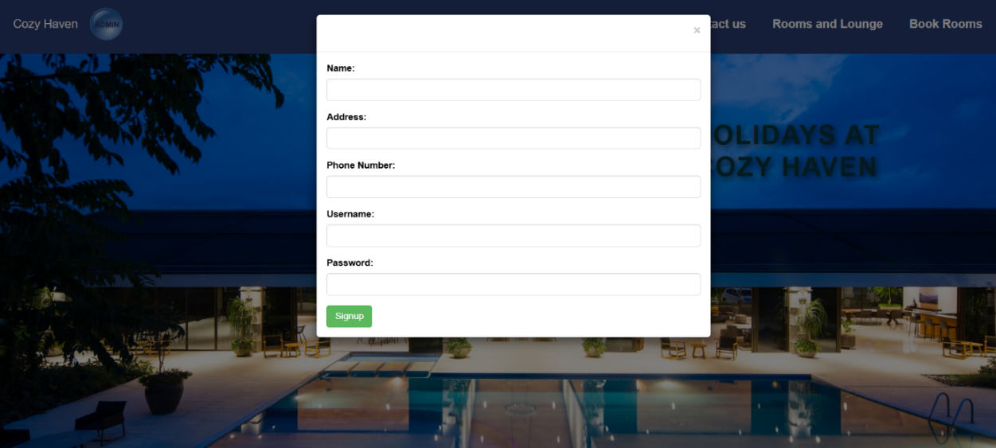

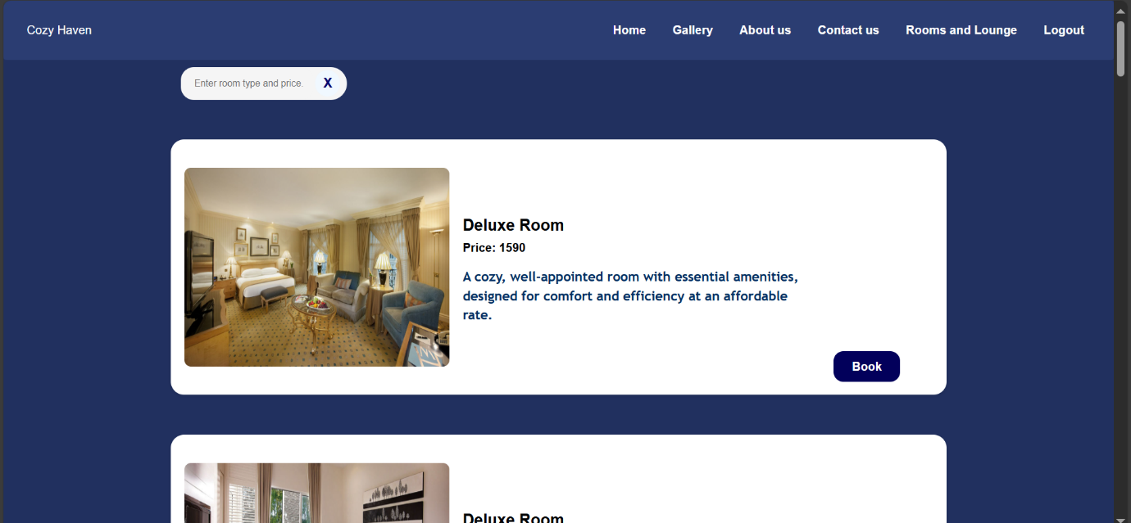



# Algorithm Codes

## Linear Search

In Algorithm.php

function linearSearchBasic($arr, $target) {

    foreach ($arr as $index => $value) {

        if (stripos($value, $target) !== false) {

            return $index;

        }

    }

    return -1;

}

function linearSearchBoolean($arr, $target) {

    foreach ($arr as $value) {

        if (stripos($value, $target) !== false) {

            return true;

        }

    }

    return false;

}

function linearSearchRecursive($arr, $target, $index = 0) {

    if ($index >= count($arr)) {

        return -1;

    }

    if (stripos($arr[$index], $target) !== false) {

        return $index;

    }

    return linearSearchRecursive($arr, $target, $index + 1);

}

function linearSearchOptimized($arr, $target) {

    $n = count($arr);

    for ($i = 0; $i < $n; $i++) {

        if (stripos($arr[$i], $target) !== false) {

            return $i;

        }

    }

    return -1;

}

?>

In Reserve.php,

$searchQuery = isset($_GET['search']) ? $_GET['search'] : '';

## Binary Search

In Algorithm.php,

function fetchRoomsFromDatabase() {

    global $conn;

  $sql = "SELECT room_id, room_type, price, photo FROM room";

    $result = $conn->query($sql);

  $rooms = [];

    if ($result && $result->num_rows > 0) {

        while ($row = $result->fetch_assoc()) {

            $rooms[] = $row;

        }

    }

    return $rooms;

}

function sortRooms(&$rooms) {

    usort($rooms, function ($a, $b) {

        return strcmp(strtolower($a['room_type']), strtolower($b['room_type'])) ?: $a['price'] <=> $b['price'];

    });

}

function binarySearchRooms($rooms, $roomQuery = null, $priceQuery = null) {

    $results = [];

      foreach ($rooms as $room) {

        $matchesRoomType = $roomQuery ? stripos($room['room_type'], $roomQuery) !== false : true;

        $matchesPrice = $priceQuery ? $room['price'] == $priceQuery : true;

        if ($matchesRoomType && $matchesPrice) {

            $results[] = $room;

        }

    }

  return $results;

}

function searchRooms($searchQuery) {

    $rooms = fetchRoomsFromDatabase();

  sortRooms($rooms);

  $roomQuery = null;

    $priceQuery = null;

    if (is_numeric($searchQuery)) {

        $priceQuery = $searchQuery;

    } elseif (strpos($searchQuery, ' ') !== false) {

        list($roomQuery, $priceQuery) = explode(' ', $searchQuery, 2);

        $priceQuery = is_numeric($priceQuery) ? $priceQuery : null;

    } else {

        $roomQuery = $searchQuery;

    }

    $searchResults = binarySearchRooms($rooms, $roomQuery, $priceQuery);

    if (empty($searchResults)) {

        $message = "No rooms found matching your query.";

        return ['results' => [], 'message' => $message];

    }

  return ['results' => $searchResults, 'message' => ''];

}

?>

In reservation.php,

<?php

$searchQuery = isset($_GET['search_query']) ? $_GET['search_query'] : '';

$searchData = searchRooms($searchQuery);

$searchResults = $searchData['results'];

$message = $searchData['message'];

?>